**Employee of the Month – February**

**Congratulations**

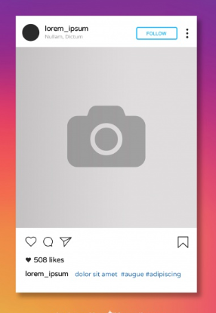

**Sabah Sehgal**

Leicester

**Sabah Sehgal** Staffing Match is the best! **#staffingmatch**

Place picture here

<Enter your content, and what they have won>



www.staffingmatch.co.uk